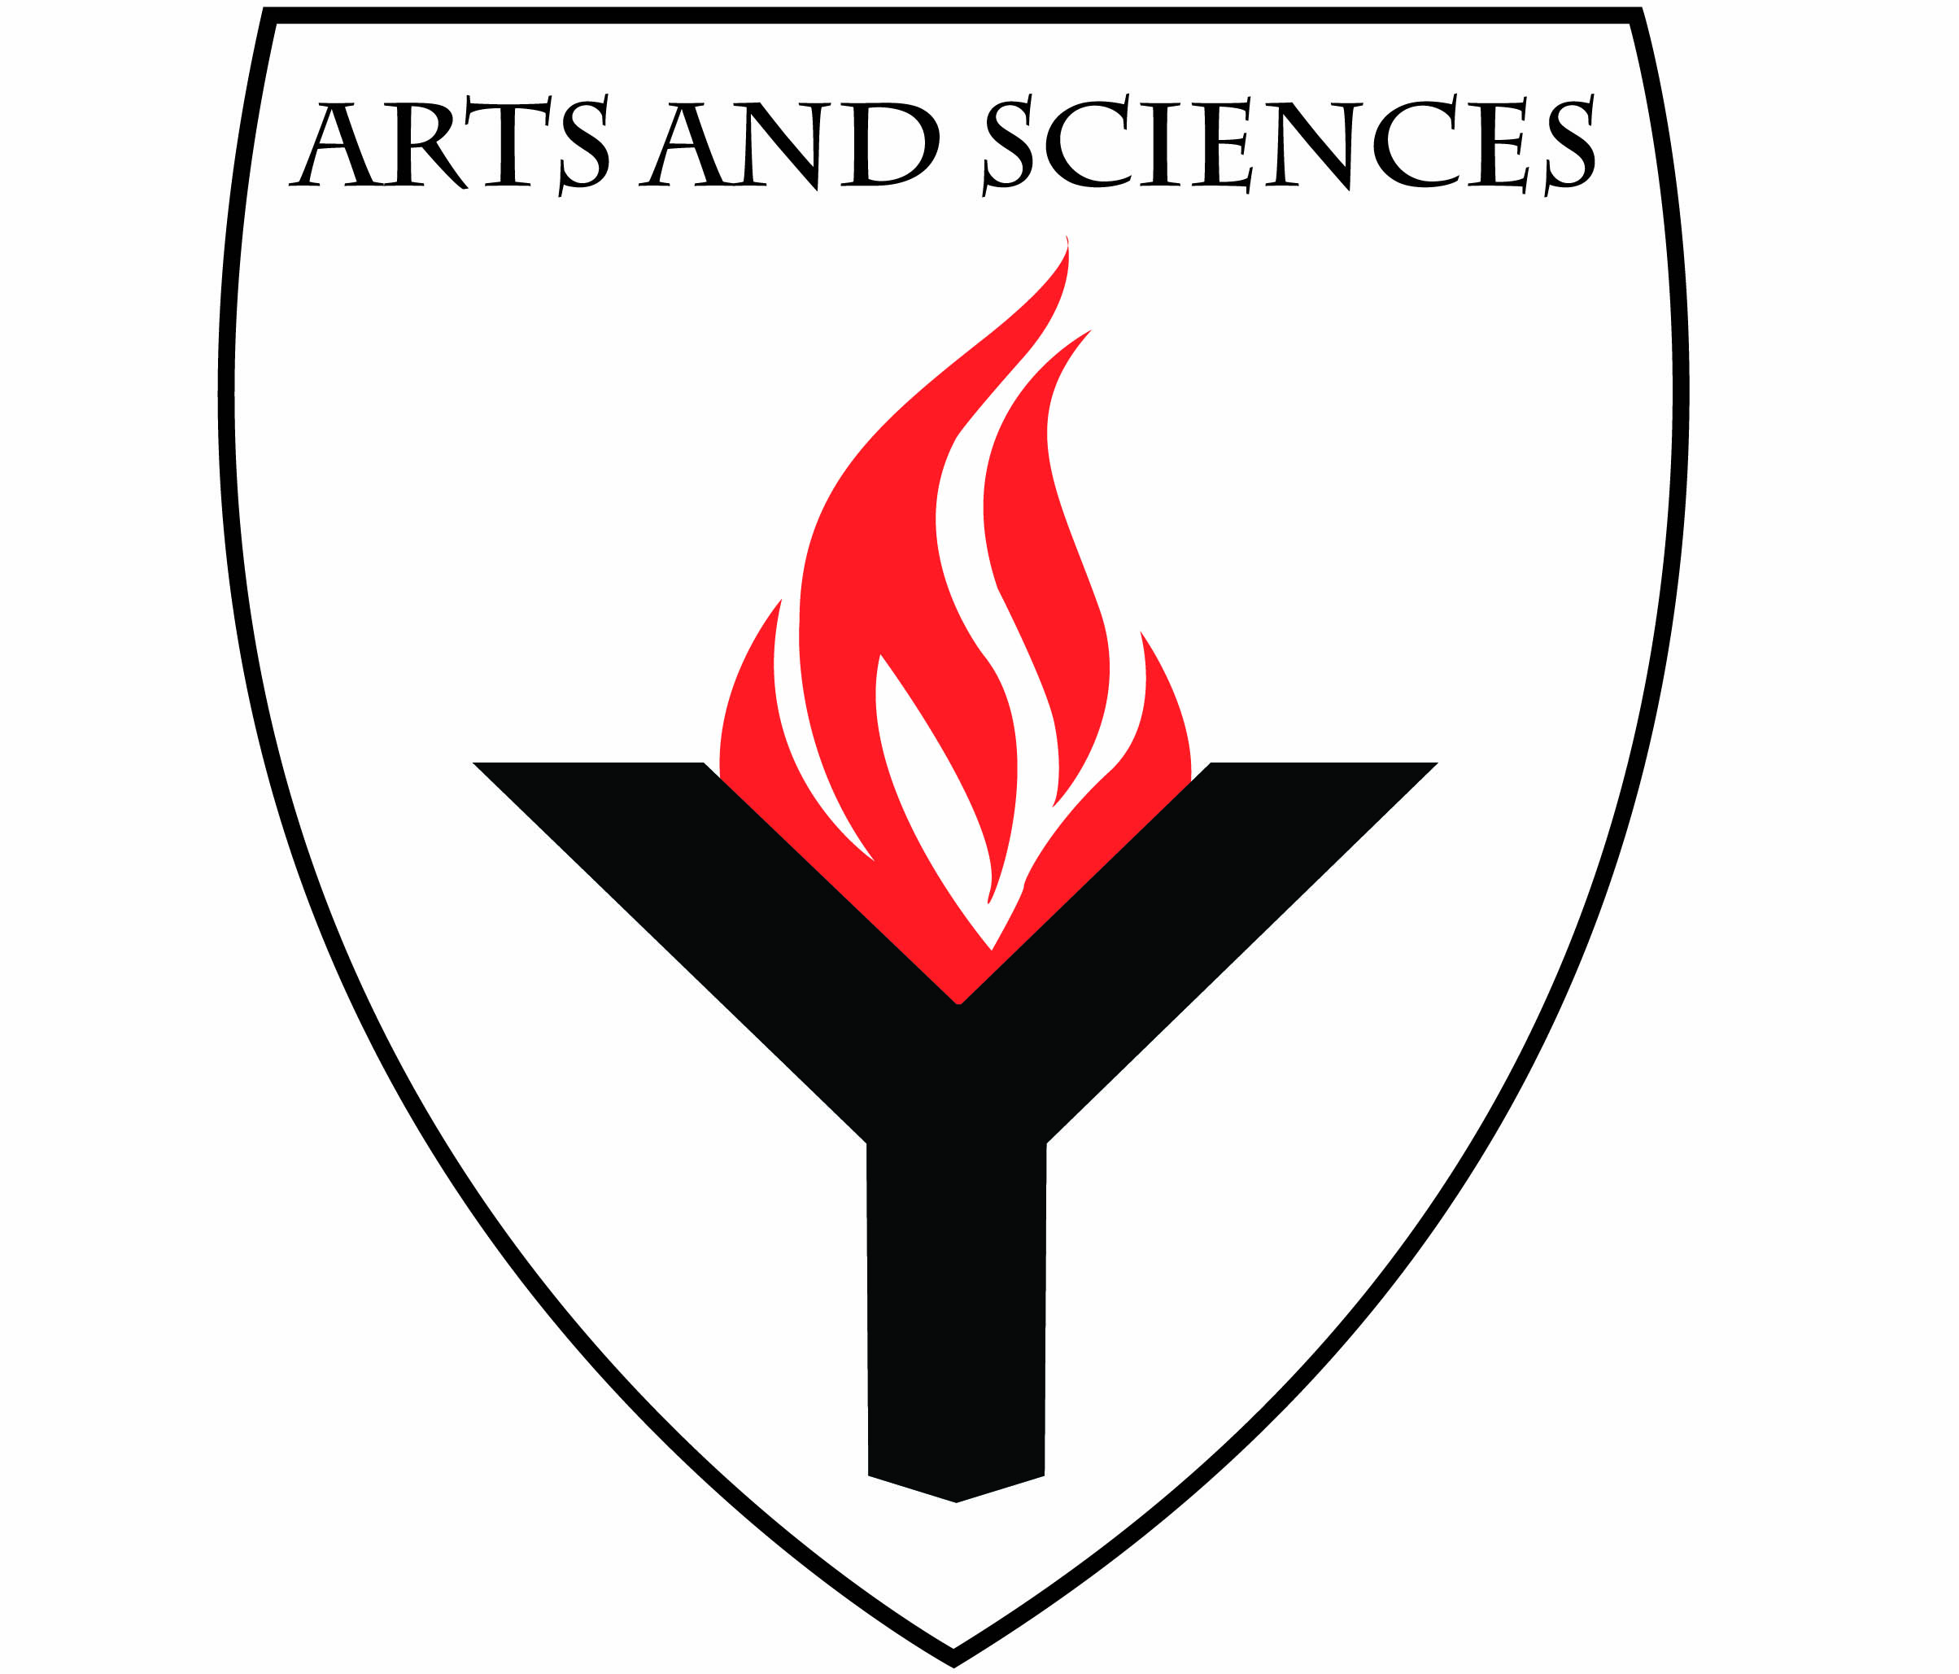
2015-2016 Pathways Major Plan
Philosophy (BA)
Department of History & Philosophy
School of Arts & Sciences
Academic Core 3D08 | 718-262-2845

The following is a suggested plan of study for completion of this degree program.
The goal of a Major Plan is to ensure that students who completed an Associate’s Degree (AA or AS) graduate with no more than 120 credits and in two years.
- All students should speak with an academic advisor about their academic programs.
This document is not a substitute for academic advisement.
- Students are encouraged to take Winter and Summer courses to facilitate their progress towards graduation.
- This plan requires transfer credit for the following courses:
  - ENGL 125 (English Composition I); PHIL 102 (Beginning Informal Logic) or PHIL 103 (Introduction to Philosophy)
  - *If you do not have transfer credit for either PHIL 102 or PHIL 103, you are able to take this course in your first semester at York.

 | Credits |  | Credits
THIRD YEAR - FALL | 15 | THIRD YEAR - SPRING | 15
College Option: Writing Intensive | 3 | College Option: Writing Intensive | 3
Free Elective: *PHIL 102 or PHIL 103 | 3 | PHIL 211 | 3
Free Elective | 3 | PHIL 213 | 3
Free Elective | 3 | PHIL Elective: PHIL 212 | 3
Free Elective | 3 | Free Elective | 3
FOURTH YEAR - FALL | 15 | FOURTH YEAR - SPRING | 15
PHIL Elective: PHIL 262 | 3 | PHIL Elective: PHIL 352 | 3
PHIL Elective: PHIL 308 WI | 3 | PHIL Elective: PHIL 351 | 3
PHIL Elective: PHIL 322 | 3 | PHIL Elective: PHIL 354 | 3
PHIL Elective: PHIL 341 | 3 | Free Elective | 3
Free Elective | 3 | Free Elective | 3

- York students are required to complete (pass) three (3) Writing intensive (WI) courses: two (2) in the lower division (100-200 level) and one (1) in the upper division (300-level).
- If you transferred to York College with an Associate’s Degree (AA or AS), or with credit for all General Education requirements, you are exempt from completing two (2) of your lower division (100-200 level) Writing Intensive (WI) courses. You must still complete one WI course in the upper division (300-level) within your major. If your major has no upper division WI course, you must take a WI course chosen in consultation with your major advisor.
- B.A. students must complete 90 credits of liberal arts – See Bulletin.
- Students are strongly encouraged to select a Minor program of study, in consultation with an academic advisor, especially those planning to attend graduate school. Minor courses would replace the “free electives” in the Two-Year Plan.

